Mississippi Gulf Fishing Banks, Inc.

MGFB Tidelands Data Summary 1 of 1
By Bob Brown
October 17, 2022

C 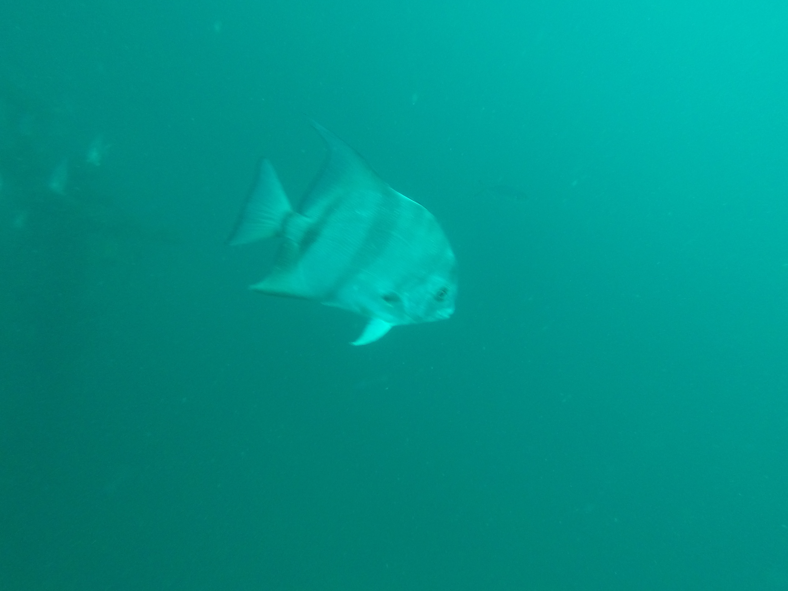

Activity Summary/ Tidelands Summary
During this period Bob Brown aka Bob the Pirate Mike Catchot and Brian Bounds performed. 1 dive trip on October 17th, 2022 to the below areas. The dive trip was in support of the Tidelands Grant for reef monitoring. Water temperature was steady around 78 degrees F on top and about the same on bottom. Waves were around 1 foot or better. The last Tidelands Grant Dive I performed was June 15, 2022.

.

FH 2 433 Shrimp Boat Captain Kevin Saw a cobia about 30+ inches on the bottom
30°05 099'N 88°33.490'W 56 Feet Deep
A dive was performed by Bob Brown

FH 13 463 Florida Limestone Pyramids
30 00 697' N 88°29 544 89 Feet Deep
A dive was performed by Brian Bounds and Mike Catchot

FH 2 503 Marquerite Concrete Culverts
30°05 041 'N 88°33.432' 58 Feet Deep
A dive was performed by Bob Brown

Sand Drop edge of FH13
30 01 878 88 29 550 74 Feet Deep
Dive performed by Brian Bounds

